5.77: See Exercise 5.40. a) The maximum tension and the weight are related by
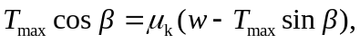
and solving for the weight w gives
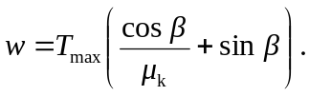
This will be a maximum when the quantity in parentheses is a maximum. Differentiating with respect to ,
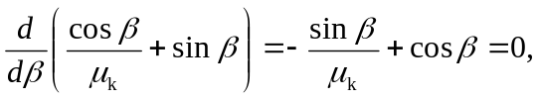
or 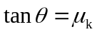, where is the value of that maximizes the weight. Substituting for 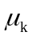 in terms of ,
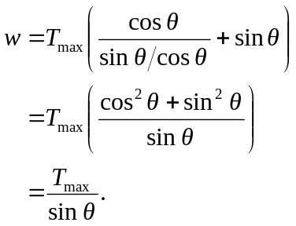
b) In the absence of friction, any non-zero horizontal component of force will be enough to accelerate the crate, but slowly.

